**CHANDRIKA WOMEN AND YOUTH FOUNDATION**



**REPORT ON CHABALA MUWE SCHOOL CLIMATE CHANGE SENSITISATION**

**Introduction**

This activity report is based on the Climate Change Sensitization and tree planting exercise which was conducted on the 19th of September 2024, and was held at Chabala Muwe Trust School of Mansa District.

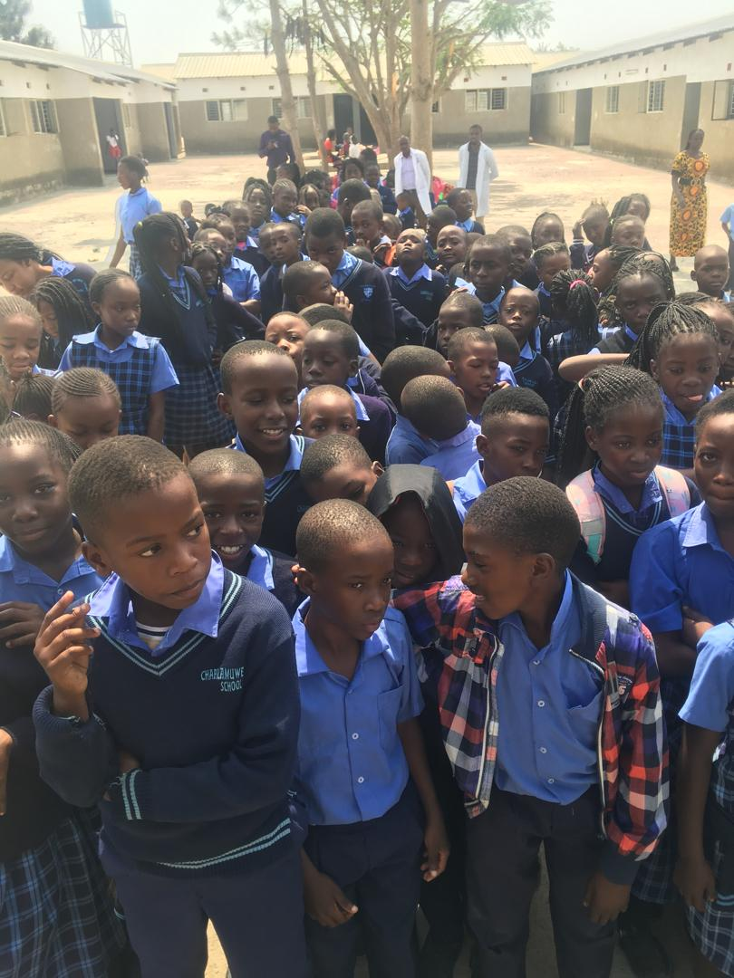***Some of the children during the sensitization on Climate Change***

**Objective**

To raise awareness among young boys and girls about Climate Change issues and to inspire eco-friendly habits and practices that promote environmental sustainability.

**Welcoming Remarks**

The program began at 09:00 hours and the welcoming remarks were given by the Amapange Yansaka Chairperson, Ms Chishala Yamuntu. The rest of the Chandrika staff introduced themselves and presented their bits respectively.

**Awareness Creation / Sensitizations on Climate Change**

**Definition of Climate Change**

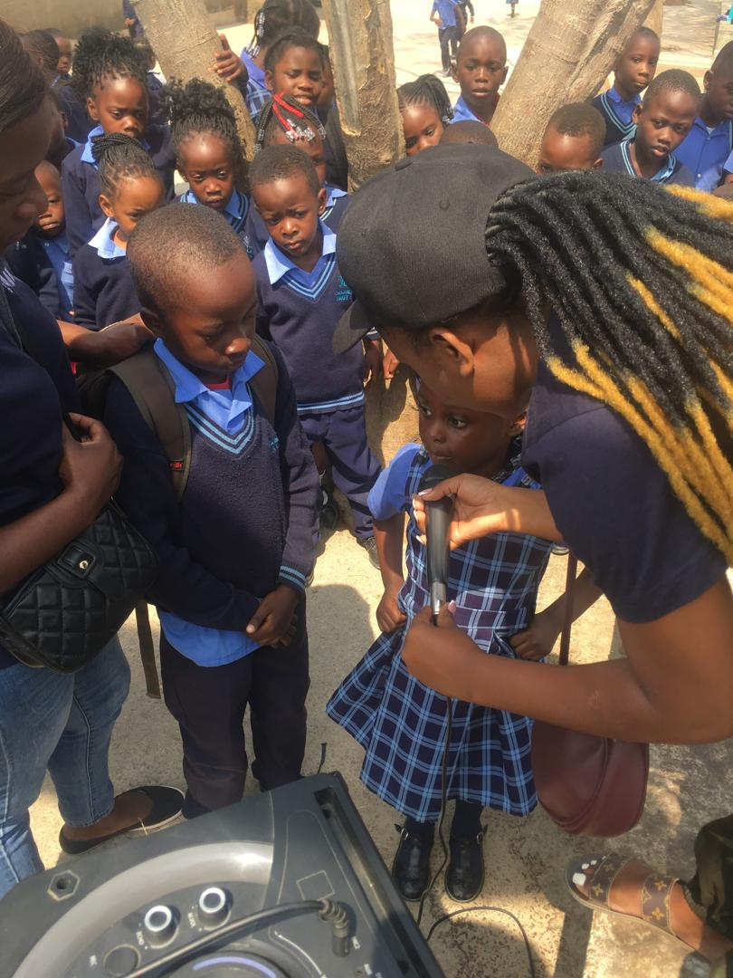

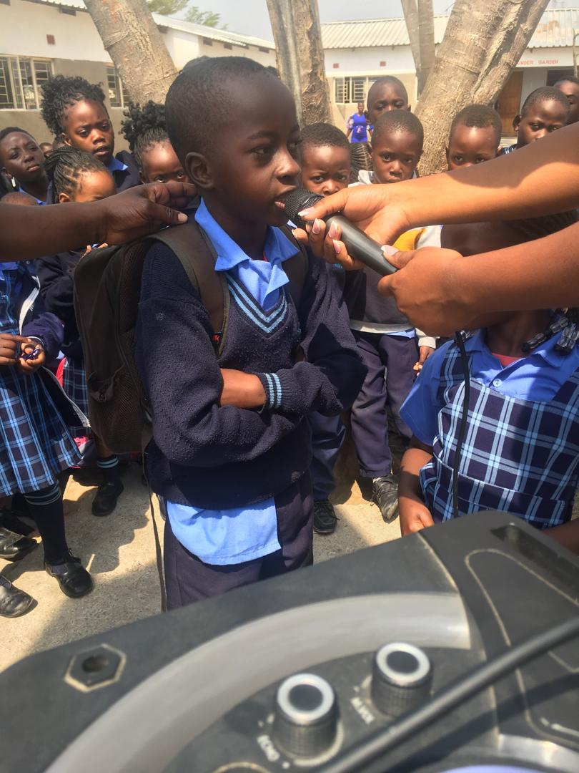The Facilitator defined Climate change as a change in the weather pattern, simply put, when the earth’s weather gets warmer and warmer over time. This happens because of bad things people have done to the planet. The Facilitator further went on to ask the children to give examples of the bad things that people do that can cause Climate Change. In response the children gave the following examples;

1. Polluting the air with dirty, smelly fumes from cars and factories
2. Cutting down too many trees
3. Using too much energy by burning fossil fuels (oil, gas, coal)
4. Leaving lights in an empty room and idle electronics on
5. Using too much water
6. Mining Activities

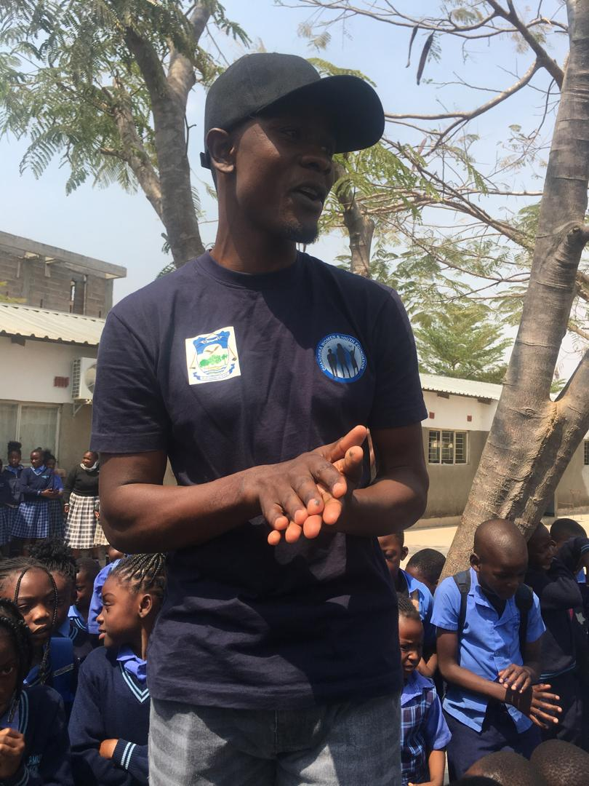Mr Bornface went on to say how all this, makes the earths temperatures rise like a fever. It’s currently very hot and that’s not how it’s supposed to be. When weather patterns suddenly change they have a negative effect on us and the environment:

***Mr Bornface explaining the effects of Climate Change***

1. Low water levels in our Kariba Dam leading to back-to-back load shedding (power outages)
2. Bush fires – bushes being burnt due to climate change (heat waves)
3. Really hot summers - like the one we’re experiencing lately
4. Super strong wind - you can almost get blown away if you’re not careful
5. Changes in seasons – it’s supposed to just be hot this month but it’s coupled with wind as if it’s August.
6. Rising sea levels - the water at Samfya beach gets too high and dangerous for little children at times

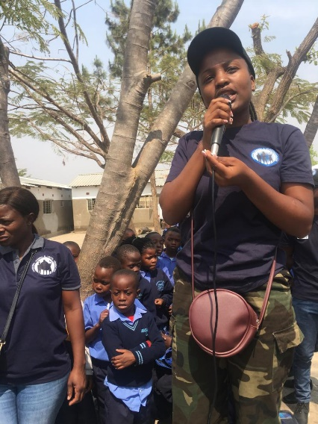We need to take care of the Earth to stop climate change. How can we take better care of planet Earth?

***Ms Chishala Yamuntu explaining how Climate Change may be mitigated***

1. Turn off lights or electronics
2. Tell grown-ups about climate change
3. Plant more trees – planting trees is the only realistic way we can replace the already cut down trees
4. Use less energy by walking or using a bicycle – if you don’t know how to ride one, now is the time to ask a friend or your caregiver to teach you
5. Reduce, Reuse and Recycle – whether you’re at home or school it’s important to recycle.

**You can recycle items such as:**

***Paper and cardboard*:** newspaper, cardboard boxes, paper towels and toilet paper rolls, old books or magazines

***Plastics*:** plastic bottles - water, juice, yoghurt containers, plastic bags

***Glass*:** jam jars, soda glass bottles

**Metal:** Aluminium cans – soda cans

**One on One Interaction**

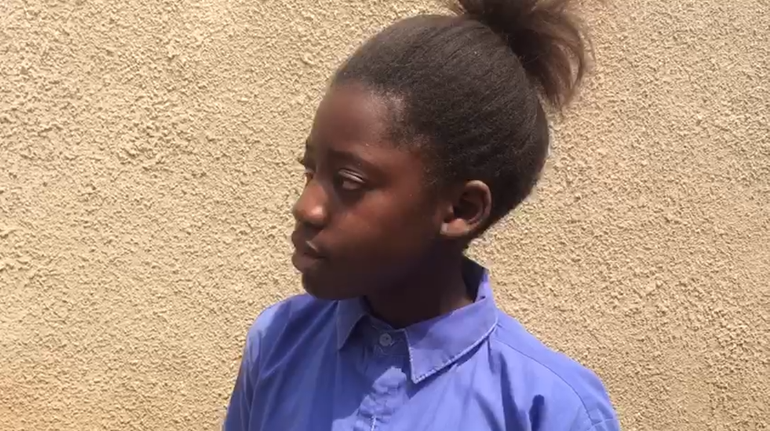Ms Chishala asked **Theresa**, who participated in the JETS Project Fare that took place recently to share some feedback on what her project was all about.

***Theresa explaining her JETS Project***

“My project talks about the environment and how we can keep the environment clean. I’ve observed that in my environment people have been throwing away banana peels not knowing that banana peels are helpful when ingested to create antibodies in their systems preventing them from falling ill unnecessarily. So I have made my project which is centred on treating them and preventing cancer from entering their bodies, as a result of in antibodies being created in them through banana peels.”

***Looking at your project relating to climate change, what do you feel we pupils can do to fight climate change?***

“We should reduce in throwing trash - littering, manage our waste and reduce the production of plastic. Instead of throwing away to make new ones we can simply recycle the already used existing plastic.”

**Maria Malindi**, a grade 7 pupil, also attended this years’ JETs Project Fare and this is what she had to say:

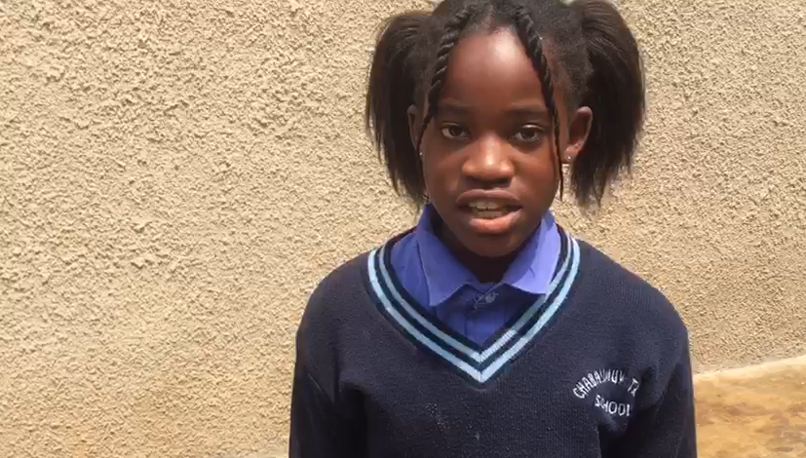“The title of my innovation was Anti Acidic Spray. The reason I came up with this innovation is because I noticed that most areas in Zambia eg Northern, Luapula, North Western and Copperbelt Provinces, we have recorded a lot of cases that the soil in those areas is highly acidic and the plants can’t grow.”

***Maria Malindi explaining her JETS Project***

“As a young scientist, upon seeing this problem caused by climate change and other factors I decided to come up with an innovation so the soil PH can be balanced. In my innovation I used egg shells, maize stalks, fish remains, pumpkin seeds, bean pods. The reason I used these materials is because each of these contain 50% of calcium magnesium and sulphuric acid.”

***So relating to your project what would you love the government to do to help you showcase your project?***

“I would love the government to take my innovation into consideration so that the soil PH can be balanced and that the agriculture sector can be boosted in our nation. A young girl from our assembly this morning said, there has been a shortage of maize meal and many other foods due to climate change. So if my innovation can be considered by the government it can help with the production of vegetables and other vital foods under the agricultural sector.”

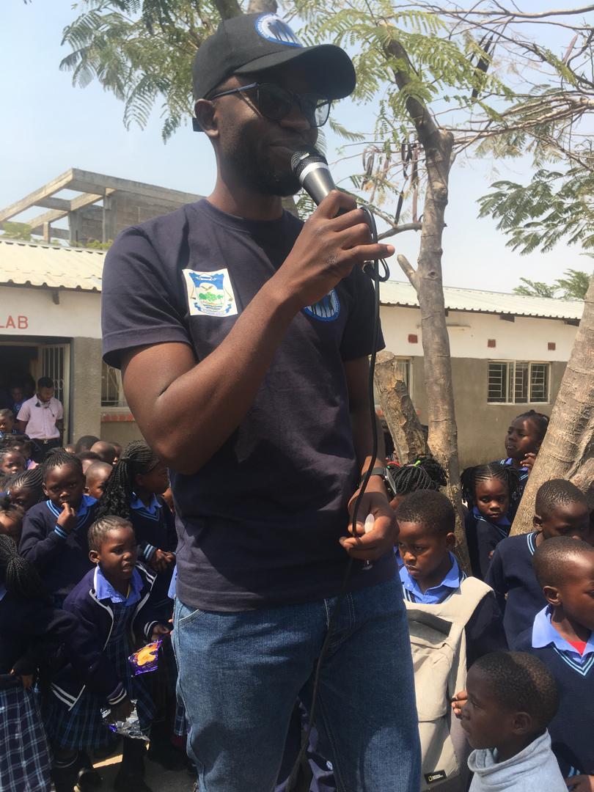

***How can you and your fellow school mates at Chabala Muwe Trust School help to fight climate change?***

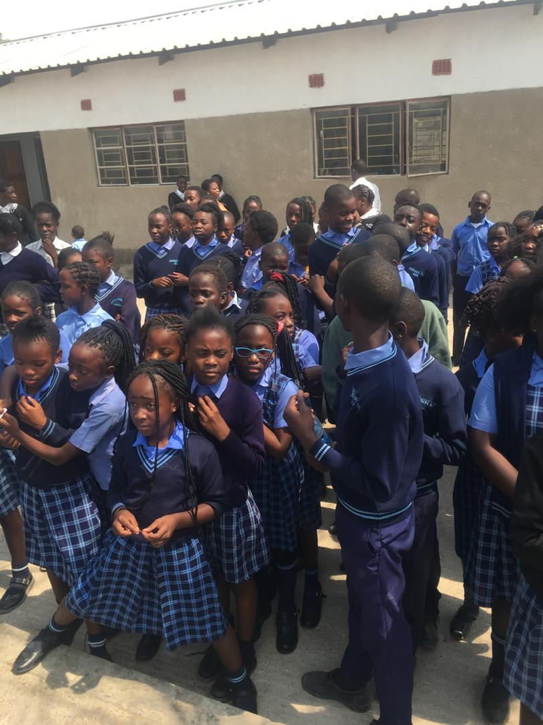

“We can begin by educating the communities, showing them the dangers of climate change to us as humans, animals and plants in the environment. Not only that, we can also reduce the production of plastic, since plastic is the most littered material, once burnt plastic emits carbon dioxide in the atmosphere, polluting the air that we breathe and environment.”

**Tree Planting**

A total of 20 trees were planted on the Chabala Muwe Trust School premises with the help of eager young boys and girls. As the trees were planted we nurtured a symbol of hope for a sustainable tomorrow. With every tree planted, we come one step closer to creating a safer, habitable planet for ourselves and future generations to live and thrive in.

**Conclusion**

The climate change sensitization and interviews were met with enthusiasm. The team was inspired to see the school already taking initiatives to address environmental issues as shared by the 2 young girls who participated in the JETs Project Fare early this year. As an organization we are confident that we have sparked a renewed sense of purpose and responsibility among students and staff. We hope to hear about the school’s continued progress in addressing climate change, reducing their carbon footprint and promoting sustainable practices.